The musculoskeletal system of the sentient is designed using that of the human body to have as much likeness to the human body as possible.

The following website is used as a base model for manipulating views for general sketch purposes. This is to draw a conclusive design. And view that I am happy with from here, the 3d model renders of the sentient are made.

https://www.msdmanuals.com/en-au/professional/multimedia/3dmodel/musculoskeletal-system-complete

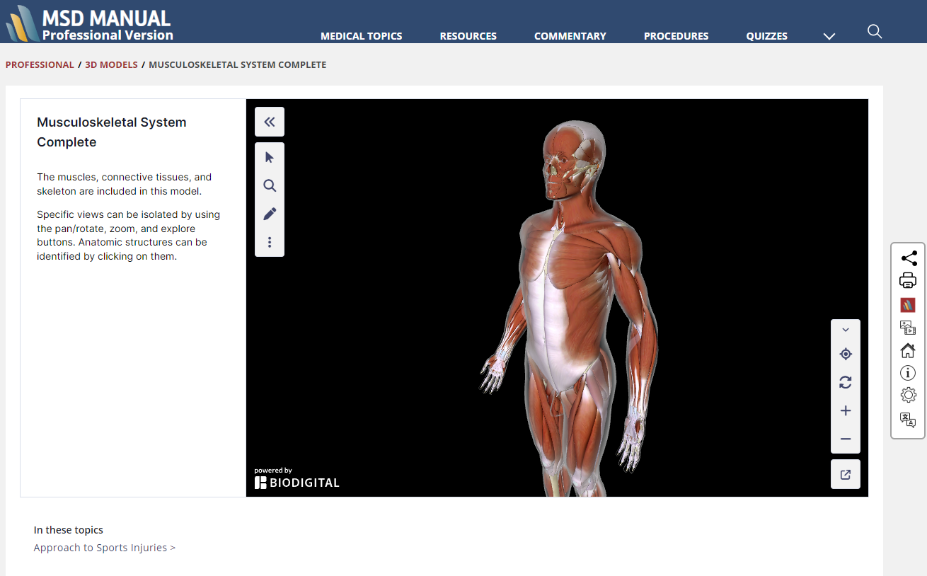

Downloading a moveable model into blender can be done here.

https://www.youtube.com/watch?v=VK0pbAEZ3wI&t=92s

The Z anatomy files are still available on Sketchfab

https://sketchfab.com/Z-Anatomy

Downloading for blender format.
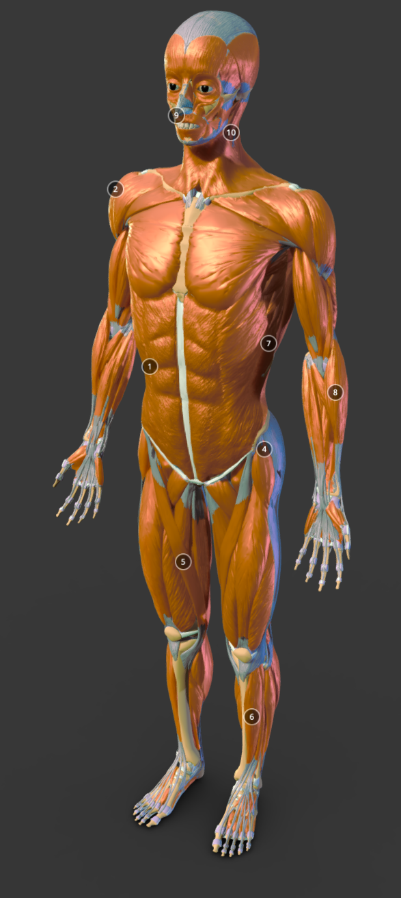
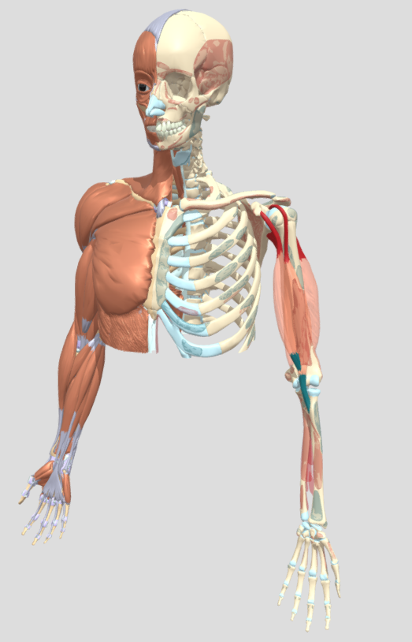

Explanation of motor neurons to muscle communication.

https://www.youtube.com/watch?app=desktop&v=gpfhkvae2FU

